Civil Registry System: A Web-Based Records Management Application

A Project Portfolio in ITE322—Technopreneurship
Presented to the Faculty of College of Computer Studies
Mindoro State University

In Partial Fulfillment
of the Requirements for the Degree of
Bachelor of Science in Information Technology

By

Michael M. Garcia

Submitted to

NICKO MAGNAYE
ITE322—Technopreneurship

May 13, 2026

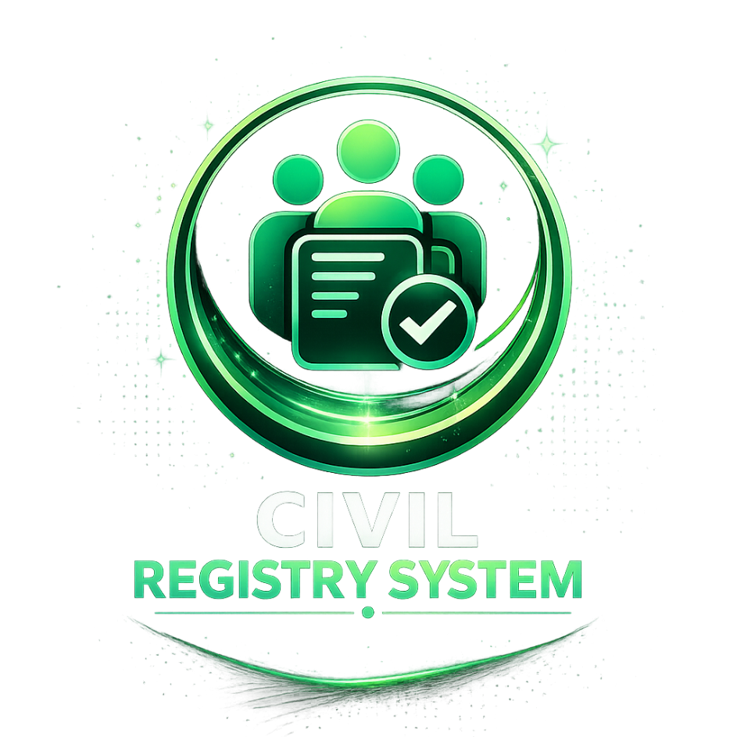

TABLE OF CONTENTS

Page
- INTRODUCTION………………………………………………………. 4
- Why Francesca Café.…………………… ……….….. 5
- NAME AND DESCRIPTION OF THE PRODUCT/SERVICE….…. 6
- BUSINESS MODEL CANVAS………………………………….……. 7
  - Value Proposition……………………………………………….…. 8
  - Customer Segments……………………………………….……… 8
  - Channel……………………………………………………….……. 8
  - Relationship……………………………………………………….. 8
  - Key Partners……………………………………………………….. 8
  - Cost…………………………………………………………………. 8
  - Key Resources…………………………………………….………. 8
    - Manpower requirements…………………………….…….……………. 8
    - Organization structure……………………………………….…………. 9
  - Key Activities……………………………………………….……… 9
  - Revenue Stream…………………………………………………... 9
- BROCHURE……………………………………………………………10
- MARKET VALIDATION……………………………….………………11
- FINANCIAL ASPECT…………………………………………………14
  - Projected Cost…………………………………………………….. 14
  - Financial Statement – Project Cash Flow……………………… 15
- PROTOTYPING………………………………………………………. 16
- PITCHING DIALOG……………………………………………………17
- CONCLUSION………………………………………………………… 18
- APPENDICES…………………….…………………………………... 19
- REFERENCES……………………………………………….……….. 24

- INTRODUCTION

Technology is really changing how places like government offices handle all sorts of records these days. It is kind of essential for keeping things organized when there is so much information to manage. With the internet getting better all the time, more agencies are switching to digital setups. This makes records more accurate, secure, and easy to get to.

Manual ways of doing this stuff take forever and often lead to mistakes. Papers get lost or misplaced, which messes up public services pretty badly. I think that is why automated systems are catching on so much.

Web-based applications help with storing documents, finding them quickly, updating data, and keeping an eye on everything. They cut down on those old problems a lot.

The Civil Registry Office deals with key things like birth certificates, marriage ones, death records, and other legal papers for the whole community. Researchers came up with this idea for a Civil Registry System, which is a web-based app for managing records.

It would let them store, organize, update, and pull up records all electronically. Administrators could handle things securely, track transactions, and keep info straight without as much hassle.

This setup should speed up operations and cut back on manual labor. Errors in handling records might drop too, improving how services work overall for people.

Through the project, it shows how tech can modernize record keeping in local spots. Make it more reliable and effective, I guess. Sometimes it feels like these changes are uneven, but they do help.
- WHY CIVIL REGISTRY SYSTEM?

People might pick this web-based system for handling civil registry stuff because it speeds things up and keeps everything more organized. It is efficient for managing records and services. The app has features that make dealing with documents easier, and transactions go smoother for office workers and regular folks.

For citizens, requesting birth certificates or marriage ones or even death records gets a lot simpler. No more waiting forever or digging through files by hand. Users can just access and verify what they need quickly. That cuts down on delays, I think. It feels more accessible overall.

Staff at the Civil Registry Office benefit too. Daily tasks simplify with organized records and monitoring transactions all in a digital setup. Secure storage for important info is a big plus. Compared to old manual ways, there is less paperwork now. Risks of losing files or messing up data drop. Employees retrieve stuff faster and manage it efficiently.

This technology pushes for modernization in public services. Stakeholders and admins would like how it boosts productivity and data security. Services become more reliable for the community. Being web-based means it is flexible and easier to handle than paper methods. Some parts of this might overlap a bit, but that is the main idea.

- NAME AND DESCRIPTION OF THE PRODUCT/SERVICE

The system they are proposing is this web app for the Civil Registry Office to handle records better. It is supposed to make everything faster and more organized, I think, especially with all those important documents like birth certificates or marriage ones. Citizens would find it easier to get services without so much hassle.

On the user side, staff can store stuff, search for it, update records, and pull them up quickly through a simple web setup. Since it is web-based, you can use it on computers or even phones, which seems pretty flexible for getting access anywhere with internet. That part makes sense for keeping things moving without being stuck in one place.

Administrators get tools to sort records, keep an eye on transactions, handle user details, and keep data straight. It cuts down on all that paper work, which is a big deal because manual stuff leads to mistakes or losing files sometimes. Digital storage helps automate a lot, so tasks do not take forever, and accuracy goes up, sort of.

Overall, this should improve how the office runs, with quicker dealings and secure handling. It feels like a step toward modernizing, but I am not totally sure how it all ties together perfectly for every situation. Some people might worry about security, others see it as just what is needed.
- BUSINESS MODEL CANVAS

Customer Segments  - Citizens requesting civil registry documents such as birth, marriage, and death certificates  - Civil Registry Office staff and administrators managing records and transactions  - Residents who need faster and more convenient public services  - Government offices requiring organized and accurate records management  - Individuals seeking secure and accessible document processing services |  | Revenue Streams  - Fees for document requests and processing  - Charges for certified copies and related services  - Online transaction and service processing fees  - Government support and service funding  - Future integration of additional digital public services
Relationship  - Customer assistance through online support and inquiry services  - User-friendly system for easier document requests and record management  - Automated notifications and transaction updates  - Secure handling of records and personal information  - Improved communication between citizens and the Civil Registry Office | Channels  - Web-based records management platform  - Mobile-responsive website interface  - Social media platforms for announcements and public information  - Civil Registry Office transactions and walk-in services  - • Online services for record requests and inquiries
Value Propositions
- Faster and more convenient records processing
- Organized, secure, and efficient records management
- Reduced paperwork and manual errors
- Improved accessibility of civil registry services
- Reliable storage and retrieval of important documents
Cost Structure
  - System development and continuous maintenance costs
- Web hosting, domain, and internet service expenses
- Hardware and equipment for office and system use (computers, servers, scanners)
- Database management and security protection costs
- Training and technical support for staff
- Operational expenses for system updates and improvements
Key Activities  • Managing online food ordering services  • Monitoring customer transactions and records  • Maintaining and updating the web system  • Promoting café products and services online  • Providing customer support and assistance  • Managing café menu and inventory records | - Key Resources  - Managing and processing online civil registry document requests  - Storing, updating, and retrieving vital records (birth, marriage, death, etc.)  - Monitoring transactions and ensuring record accuracy  - Maintaining and improving the web-based system  - Providing assistance to users and office personnel  - • Ensuring data security, backup, and system reliability
Key Partners

  - Internet and hosting service providers
• Local suppliers of food and café materials
• Technology providers and developers

The Business Model Canvas (BMC) is a strategic management tool used to describe, design, and analyze how an organization creates, delivers, and gains value. It provides a visual framework that helps organizations understand important aspects such as users, operations, resources, partnerships, costs, and sources of value delivery. The Business Model Canvas is important because it helps organizations plan effectively, identify opportunities, improve decision-making, and develop strategies for operational efficiency and sustainability.

In this study, the researchers developed the Business Model Canvas for the “Civil Registry System: A Web-Based Records Management Application” by identifying the target users, services offered, operational requirements, resources needed, and possible benefits of implementing the system. The researchers analyzed the current manual processes of civil registry record management and integrated technology-based solutions that can improve records handling, document retrieval, and overall management efficiency.

a. Value Proposition
The proposed system provides a fast, secure, and user-friendly platform for managing civil registry records. It allows authorized users to store, retrieve, update, and manage documents efficiently through a web-based application. The system improves record accuracy, minimizes manual paperwork, enhances data security, and speeds up document processing and retrieval for both administrators and clients.
b. Customer Segments
- Local government offices and civil registry staff
- Residents requesting civil registry documents
- Administrators and authorized personnel
- Individuals requesting birth, marriage, or death records
- Government agencies requiring civil registry information
c. Channel
- Web-based records management platform
- Mobile-responsive website
- Local government office transactions
- Online announcements and information dissemination
- Social media pages for updates and public information
d. Customer Relationship
- User support and assistance
- Automated notifications and status updates
- Secure and user-friendly self-service access
- Feedback and inquiry system
- Efficient document request and processing services
e. Key Partners
- Local government units (LGUs)
- Information Technology service providers
- Internet and hosting service providers
- Database and security management providers
- Community and government agencies
f. Cost Structure
- System development and maintenance expenses
- Website hosting and internet connection costs
- Hardware and equipment expenses
- Employee salaries and operational costs
- Security and database management costs
- System upgrade and technical support expenses
g. Key Resources
- Web-based records management system
- Database servers and storage facilities
- IT personnel and system administrators
- Internet connectivity and networking equipment
- Security and backup systems
- Civil registry records and digital documents
Person | Requirements / Responsibilities
Civil Registrar | Responsible for supervising daily civil registry operations, approving document requests, and managing registry personnel and transactions.
System Administrator | Responsible for maintaining the web-based system, managing records and user accounts, ensuring database security, and monitoring system performance.
Registry Staff | Handles document encoding, record updating, verification of civil registry documents, and assists clients with requests and transactions.
Clients / Residents | Users who request, access, and verify civil registry documents such as birth, marriage, and death certificates through the system.

    - Organization structure

The organizational structure of Francesca Café follows a simple management hierarchy to ensure efficient operations and proper communication among staff members. The Café Manager oversees the overall business operations and supervises all departments. The System Administrator manages the technical aspects of the web-based system. The Cashier and Café Staff handle customer services and transactions, while the Kitchen Staff prepares customer orders. The Marketing Staff is responsible for promoting the café and maintaining customer engagement through digital platforms.

  - Key Activities
• Managing customer food orders and transactions
• Maintaining and updating the web-based system
• Monitoring café sales and records
• Preparing and serving food and beverages
• Promoting products and services online
• Providing customer support and assistance
  - Revenue Stream
• Sales from food and beverage products
• Online ordering transactions
• Delivery service fees (future implementation)
• Promotional partnerships and advertisements
• Customer loyalty and repeat purchases

- BROCHURE

